Faculty of Information Technology (FIT) – Ho Chi Minh City University of Science (HCMUS)
CS423 / CSC13003 – Software Testing (AI-augmented · 2026)
AI POLICY · TEMPLATES — 2026 v1.0

AI Audit Report — 5-section Template per Artifact
Mandatory appendix for every AI-assisted homework (HW#01–HW#06, and Seminar).
Adapted from Med Kharbach, PhD (2026) — AI Use Policy Templates for Higher Education. CC BY-NC-SA 4.0. This adaptation is prepared for FIT@HCMUS – CS423 / CSC15003 Software Testing course.

1. Student Information
Field | Value
Student name (printed): | Ngô Thế Đạt
Student ID: | 23127340
Class / Cohort: | 23KTPM3
Assignment ID (e.g., HW#00, HW#02): | HW0
Assignment date:
AI tool(s) used: | Gemini, Claude
AI tool(s) used: | [ ] Yes [ ] No

2. Instructions (read before filling)
- Add one row per AI-generated artifact (test case, script, checklist, OpenAPI spec, JMeter plan, etc.).
- Paste the verbatim prompt — DO NOT paraphrase.
- Paste the verbatim AI output (or include a labelled screenshot in the report).
- Tag the verdict: VALID / INVALID / INCOMPLETE.
- Reasoning must cite a course slide, ISTQB section, or technical RFC.
- Show the corrected artifact with the change highlighted.
- Sample rows are in italic — replace them before submission.

3. Audit Table — one row per artifact
(1) Prompt + Tool | (2) AI Output | (3) Verdict | (4) Reasoning (ISTQB) | (5) Student Fix
Sample (italic) — replace before submission:
Tool: AI Tool (e.g., ChatGPT, Claude, Gemini)  Time: 14:32 25/02/2026  Prompt:  "Generate test cases for parsePhoneNumberVN function…" | TC01: parsePhoneNumberVN("0912345678")  Expected: {prefix:84, number:912345678, valid:true}  … | INCOMPLETE | AI ignored RFC 3966 international format. ISTQB FL §4.3 Boundary Value Analysis requires testing format edges. | Added TC: parsePhoneNumberVN("+84-91-234-5678")  Expected: {prefix:84, number:912345678, valid:true}
Artifact #1
Artifact #2
Artifact #3
Artifact #4
Artifact #5
Artifact #6
Artifact #7
Artifact #8
Artifact #9
Artifact #10

4. Summary of AI Accuracy
Aggregate the verdicts from Section 3 and complete the table below.
Metric | Count | Percentage
Total AI-generated artifacts audited
VALID (correct, accepted as-is) |  | %
INVALID (wrong; rejected) |  | %
INCOMPLETE (acceptable after edits) |  | %

5. Conclusion — When should AI be used (or not)?
Write 80–150 words describing patterns you observed. Where did AI shine? Where did AI fail? What is your recommendation for using AI in this kind of work in the future?

6. Mandatory Disclosure (paste verbatim)
"[Test cases / script / dataset / report] was initially generated by [AI tool name]; I reviewed and modified [section X], added [edge cases Y, Z]; [section W] was written entirely by me. The detailed AI Audit Report is attached as Appendix A. I confirm I did not use AI to generate any artifact listed in the prohibited category."

Signature
Student name (printed): | Ngô Thế Đạt
Student ID: | 23127340
Class / Cohort: | 23KTPM3
Course: | CS423 / CSC13003 – Software Testing
Instructor: | Hồ Tuấn Thanh
Date:
Signature: | 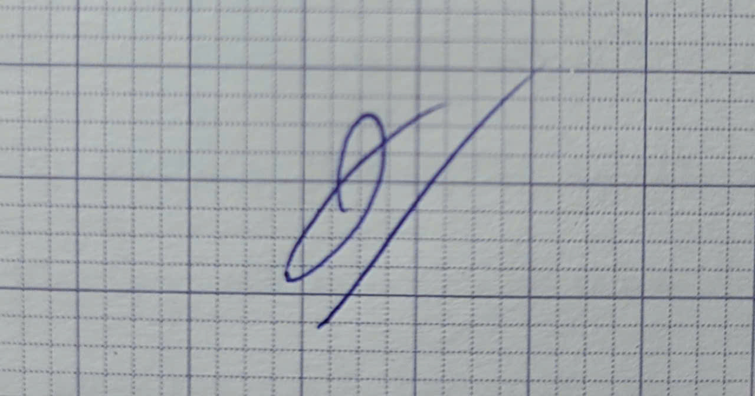

References
- Kharbach, M. (2026). AI Use Policy Templates for Higher Education. CC BY-NC-SA 4.0.
- ISTQB Foundation Level Syllabus (latest version).
- Hardman, P. (2025). A Post-AI Learning Taxonomy.
- Fuster Rabella, M. (2025). OECD Education Working Paper No. 338.
- Perkins, M., Roe, J., & Furze, L. (2025). AI Assessment Scale.
- Anthropic (2025). Building reliable AI test agents — engineering blog.
- DeepEval & Promptfoo documentation — testing frameworks for LLM systems.

